Chief Bitesalot 2016  Floyd Cove Nursery | (Pierce G) 2146-M (Spinefeld x Hooked) x unknown  EM re EV emo 36” 7.25” flower, 5 way branching, 40 buds, fragrant | 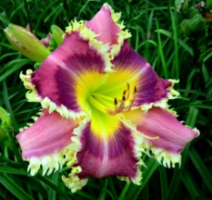
Venetian Pools 2016  Floyd Cove Nursery | (Pierce G) 338-A Rings of Wonder x (Get Jiggy x Supernatural)  EE re EV emo 30” 6.5” flower, 5 way branching, 35-40 buds. | 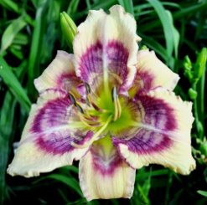
Big 8 2016  bonus  Floyd Cove Nursery | Pierce G) 1486-D (Buffalo Thunder x Ruby Ridge)  EE re EV 34” 8” flower, 5 way branching, 40 buds, fragrant. | 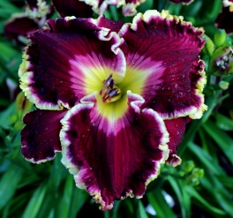
Max Factor 2015  bonus  Floyd Cove Nursery | (Pierce G.) 1406-DD ((Buffalo Thunder x Colossus) x Mayans’ Dawn)  TET EV EM RE 42” 8.25” flower, 6 way branching, 35-40 buds.
Dental Delight  Kennesaw Mountain Daylily Gardens | Bill Waldrop 2016 ((Shirley Anne McCord x Gnashing of Teeth) x (Shirley Anne McCord x Gnashing of Teeth))  Dor. Tet. Mid-season blooms. 28" tall, 5-way branching, 25 buds 5.5" flower | 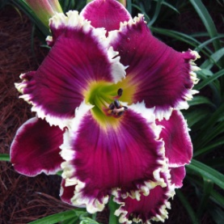
Opa Klaus  Kennesaw Mountain Daylily Gardens | Bill Waldrop 2016 (Buzz Saw Boogie x Tet. Sunglasses Needed)  Ev. Tet. Double. Early to Mid-season blooms. 26” tall, 4-way branching, 18 buds, 10” flower | 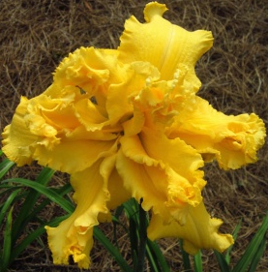
Artillery Fire  bonus  Kennesaw Mountain Daylily Gardens | Bill Waldrop 2016 (Wild and Free x Walt Lowry)  Sev. Tet. Early to mid-season blooms. 44” tall, 4-way branching, 23 buds, 12” flower. | 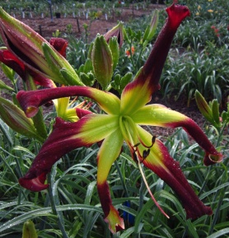
Irish Royalty  bonus  Kennesaw Mountain Daylily Gardens | Bill Waldrop 2015 ((Shirley Anne McCord x Marietta Heartbeat) x The Ultimate Sacrifice))  Sev. Tet. EM. 28" Tall, 4-way branching, 26 buds, 6" flower | 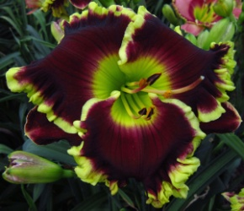
Emerald Fangs  Heavenly Gardens | (Gossard, James) 2016 (Grace seedling x Dr Celia Stump ) x ((Heavenly Pink Fang x Bass Gibson) x Spartan Warrior)  Tetraploid 35" Early Midseason Semi-Evergreen emo fr 6" 3-4 way branching 18-24 buds. Fertile both ways. Rebloomer | 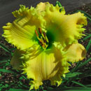
Vampire Lady  Heavenly Gardens | (Gossard, James) 2016 (Interview with a Vampire) x (Vampire Fish)  Unusual Form Type : Crispate  Tetraploid 36" Mid Late Season Dormant emo fr 8.5" 3-4 way branching 18-24 buds. Fertile both ways. Rebloomer. | 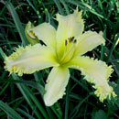
Man Eating Bat  Heavenly Gardens | (Gossard, James) 2016 (Unfolding Mysteries) x (Vampire Bat)  Tetraploid 37" Midseason Semi-Evergreen emo fr 8.5" 3 way branching 18-20 buds. Fertile both ways. Rebloomer. | 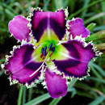
Ultimate Illusion  Heavenly Gardens | (Gossard, James) 2016 (Complicated x Captain America ) x (Magician`s Apprentice)  Diploid 27" Midseason Dormant emo fr 5" 3-4 way branching 18-24 buds. Fertile both ways. Rebloomer. | 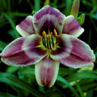
Shockware Grenade  bonus  Heavenly Gardens | (Gossard, James) 2016 (Queen of the Desert) x (Blue Swallowtail )  Tetraploid 27" Early Midseason Semi-Evergreen emo fr 5" 4-5 way branching 22-25 buds. Fertile both ways. Rebloomer. | 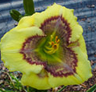
Reindeer Games  bonus  Heavenly Gardens | (Gossard, James) 2016 (Dark Mosaic x Black Eyed Jester ) x (Squirrelly)  Diploid 32" Midseason Dormant emo fr 5" 3-4 way branching 20-24 buds. Fertile both ways. Rebloomer.  Unusual Form Type : Crispate-Spatulate | 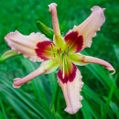
Emperor’s Crocodile  bonus  Heavenly Gardens | (Gossard, James) 2016 (Pixie Pinwheel Party) x (Emerald Starburst)  Diploid 28" Early Midseason Dormant emo fr 6" 3-4 way branching 18-24 buds. Fertile both ways. Rebloomer. Sculpted Type : Cristated | 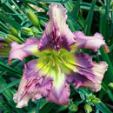
Ring of Magnetism  bonus  Heavenly Gardens | (Gossard, James) 2016 ((Time Stopper x (Smoke Scream x Kaleidoscope Effect)) x (diploid Canary Bird Song )  Diploid 36" Midseason Dormant emo fr 7.5" 3-4 way branching 18-24 buds. Fertile both ways. Rebloomer. | 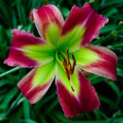
Electric Snake  bonus  Heavenly Gardens | (Gossard, James) 2016 (Square Dancer`s Curtsy ) x (( Oakes Love x Tomorrow`s Song) x (Heavenly Spider Monkey ))  Diploid 30" Midseason Dormant emo fr 10" 3-4 way branching 18-24 buds. Fertile both ways. Rebloomer. Unusual Form Type : Crispate-Cascade | 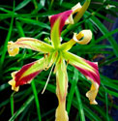
Heavenly Snow Flake  bonus  Heavenly Gardens | (Gossard, James) 2016 (Polar Bear Express) x (Ghost Ranch )  Diploid 30" Midseason Dormant emo fr 9" 3-4 way branching 18-22 buds. Fertile both ways. Rebloomer. | 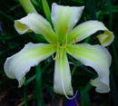
Snarl  bought 2  Heavenly Gardens | (Gossard, James) 2016 (Overdrive ) x (Thundercat )  Tetraploid 27" Mid Late Season Dormant emo fr 7.5" 3-4 way branching 18-22 buds. Fertile both ways. Rebloomer | 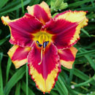
Snarl  bonus of 2  Heavenly Gardens | (Gossard, James) 2016 (Overdrive ) x (Thundercat )  Tetraploid 27" Mid Late Season Dormant emo fr 7.5" 3-4 way branching 18-22 buds. Fertile both ways. Rebloomer
Small World Christmas Eve  Small World Gardens | (Miller, M, 16) ( ‘Small World Cross Fire' X ' Heavenly United We Stand')  Tet, Dor., Ml., Re., 50", 8.5", 5 way branching carrying 26 bc. Red with bold green throat. | 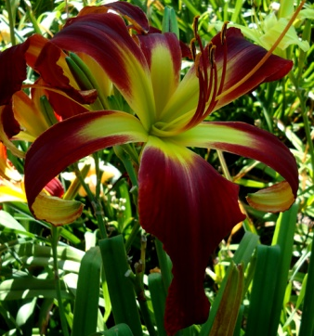
Small World New Year's Eve  Small World Gardens | (Miller, M, 16) Tet, sw-sp-32-t-12 ( ‘Rolling Raven' X ' Heavenly United We Stand')  Sev., L., Re., 60", 8.5", 4 way branching carrying 20 bc. Wine black with a bright yellow to green throat. | 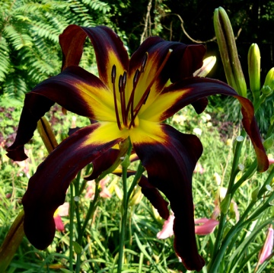
Small World Mango Habanero  Small World Gardens | (Miller, M, 16) Dip, sw-sp-400a-d-12 ( Reed Seedling X ' Small World Grasshopper')  Dor., Ee., Re., 44", 8.5", 4-5 way branching carrying 30 bc. Great mango orange with a glowing waxy green throat. | 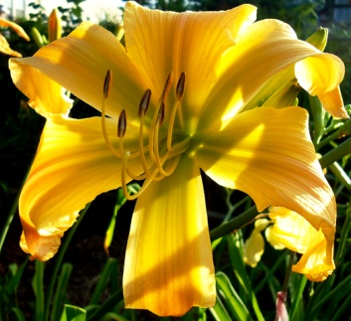
Small World Sky Line Drive  Small World Gardens | (Miller, M, 16) Dip, sw-sp-400-d-12 ( Reed Seedling X ' Small World Grasshopper')  Dor., Ee., Re., 44", 8", 4-5 way branching carrying 30 bc. Cream yellow with a green throat. | 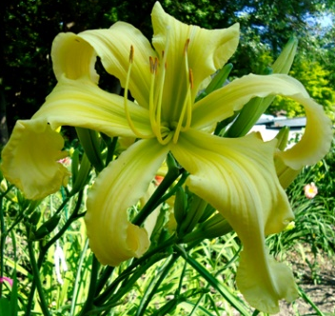
Small World Strawberry Cream Puffs  Small World Gardens | (Miller, M, 16) Tet, sw-dbl-5-t-12 (‘Small World Ellen Brous' X ' Small World Kaleidoscope' )  Dor., E., Re., 32", 4.78", 4- way branching carrying 18 bc. Lavender water color with green throat. | 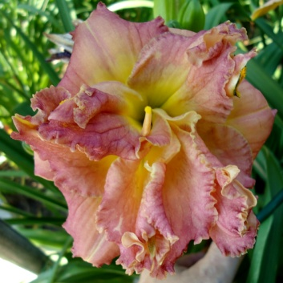
Small World Crazy Eyes  Small World Gardens | (Miller, M, 16) Tet, sw-10-t-12 ( ‘Crazy Ivan' X ' Small World Sight For Sore Eyes')  Dor., E., Re., 37", 5", 4 way branching carrying 20 bc. Cream with bold black plum eye and edge. Has midribs. It also has a EYE of gray glitter outside the throat color. Green throat. | 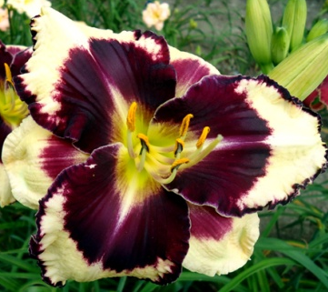
Small World Jonathan Smith bonus  Small World Gardens | (Miller, M, 16) Tet, sw-sp-27-t-12 ( ‘Heavenly Orange Blaze' X ' Ed Jordan')  Dor., E., Re., 42", 7", 4-5 way branching carrying 28 bc. Glowing on fire orange with darker halo. Green throat. | 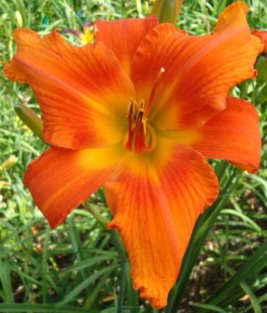
Small World First Snow bonus  Small World Gardens | (Miller, M, 16) Tet, sw-65-t-12 ( ‘Small World Matthew' X ' Last Snowflake')  Dor., e., Re., 37", 6.5", 5 way branching carrying 28 bc. Cream white with a ruffled gold edge. Green throat.
Small World Chadlie Gage bonus  Small World Gardens | (Miller, M, 16) Tet, sw-76-t-12 ( ‘Mike Longo' X ' Felicia Grace') Dor.,  M., Re., 36", 5.5", 4 way branching carrying 22 bc. Cream peach blend with a gold edge. Sculpted relief. | 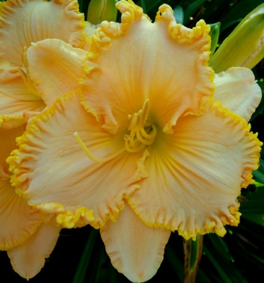
Small World Sea of Serenity bonus  Small World Gardens | (Miller, M, 16) Tet, sw-sp-18-t-12 (‘Small World Sea Breeze' X ' Tet Heavenly Angel Ice)  Dor., E., Re., 35", 7", 4- way branching carrying 24 bc. Cream white with green throat. | 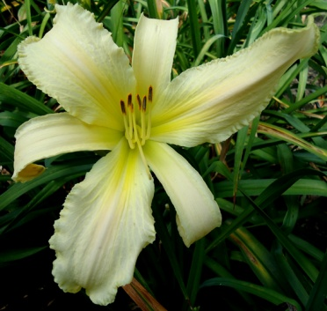
Small World Laughing Clown bonus  Small World Gardens | (Miller, M, 16) Tet, sw-sp-44-t-12 ( ‘Small World Cross Fire' X ' Small World Christmas Candy ')  Dor., M., Re., 48", 7", 4-5 way branching carrying 26 bc. Cherry red with glowing green throat. Lighter watermark. | 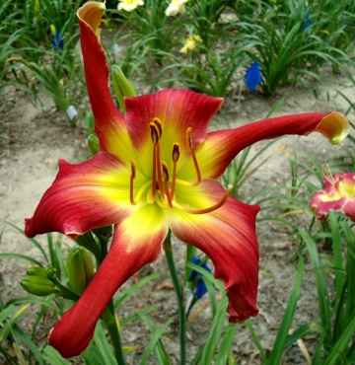
Small World Cabernet  bonus  Small World Gardens | (Miller, M, 16) Tet, sw-7-t-12 ( ‘Small World Ruby Red' X ' Hot Gossip')  Dor., Ee., Re., 34", 6", 4 way branching carrying 20 bc. Wine red with a darker Halo. Green throat. | 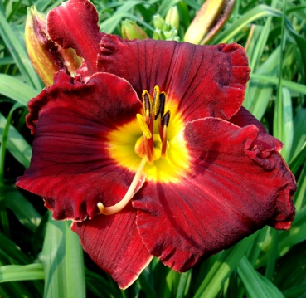
Small World Texas Pete  bonus  Small World Gardens | (Miller, M., ’15) Tet., sw- 17-t-10 (‘Small World Barbeque Chip’ X ‘Spacecoast Small Talk’)  Dor., Ee., Re., 30”, 4.5”, 5-way branching, 26 BC. Hot orange with cherry red eye and edge. | 