RADS Newsletter, Spring 2016

|  |
| --- |
| RADS Officers for 2016  President Vice President  Paulette Miller Pam George  Treasurer Secretary  Leo Rutledge Julia Perkinson |

**JAMIE IS COMING! JAMIE IS COMING!**

**Come one come all! March 12th The one the only James Gossard will be speaking to us and showing us his new daylilies! And let me tell you if you did not see them on Monday Night Lights you are in for a SURPRISE!!!! They are knock your socks of GORGEOUS!!! HE IS BRINGING PLANTS!!!!**

**SOOOOO bring a friend, a dish and money and come join us for a day of GREAT daylilies, GREAT friends, and lots of FUN!**

NOTES:

**Dues are now past due. Please send in ASAP.**

Upcoming Events:

April 23

11:00 Meeting & Auction for Plants for Members

May 6th & 7th

Lewis Ginter Spring Plant Sale - Please donate plants Let Michael know what you can give

June 18th

Daylily Show & Sale @ Lewis Ginter

Again we will need plant donations

June 29th – July 2nd

AHS National in Louisville, KY

#### RADS Web Site http://myrads.com

President's Message

 Hopefully spring is right around the corner. It's been a long and hard winter and all though daylilies do well under a blanket of snow I do not do as well.

I'm sorry I was unable to attend the first two get togethers, I was busy taking Brenden to basketball.

Hope to see everyone on the 12th.

Happy Gardening

Paulette

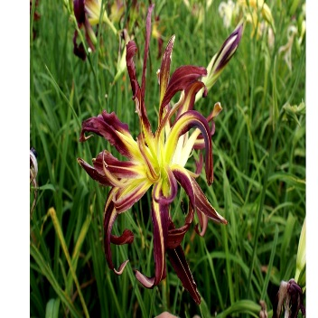

©[Year] [Book Club Name]