RADS Newsletter, Summer 2016
July 24th 11-2
Deep Run Park
9900 Ridgefield Parkway
Henrico, Va 23233
Shelter 4
There will be a short business meeting about the nominating committee prior to the picnic.
The club will provide the hamburgers, hotdogs, paper products, and drinks. Please bring a covered dish or dessert to go along with the hamburgers and hotdogs!
Hope to see you there!

Plant Swap will be held on Aug 20th at Serenty Hill Garden in Dinwiddie. Mark the date and start potting your plants now!

RADS Web Site http://myrads.com
President's Message

I hope you all enjoyed your daylily blooming season as much as I did. We had lots and lots of rain this year but what seems like a short season to me. But the daylilies did there thing and beautifully too. Be sure to check out upcoming activities planned. Please consider volunteering for our club. We need all of you. Many hands make light work.

Happy Gardening
Paulette Miller.
THE NATION IS COMING !!!!

Norfolk is the place to be next summer. And we as a club have a chance to win $500!!!
All region 3 clubs are being asked to design and donate baskets to be auctioned off at the National next summer and the most creative basket will be awarded $500! So let’s all put our thinking caps on and get to designing that winning basket!

And make plans to be at the National in Norfolk!!

We are looking for someone to volunteer to be the new newsletter editor. Please contact Paulette.

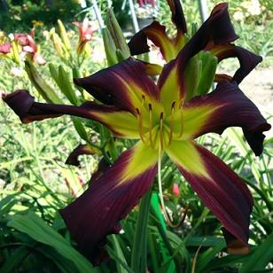

©[Year] [Book Club Name]

