THE GARDEN ART OF DAVID JERRELL

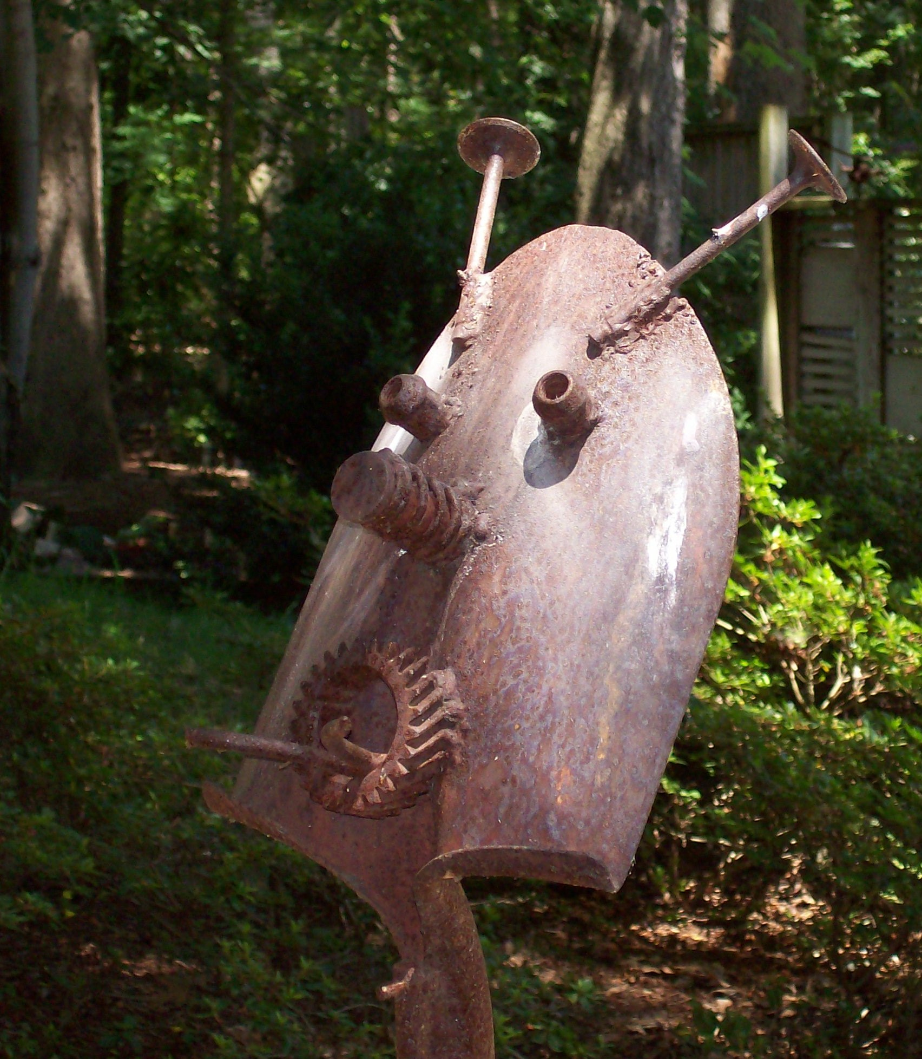

Region 3 recently lost not only one of its most kind and generous members but also one of the most talented. David Jerell was well known for his whimsical creations of garden art used to bring smiles of delight to visitors in many of the daylily gardens in the region.

Bob Phillips has been a friend of David for over 40 years. When I asked him about the early days of David’s Garden art he replied that “David just kind of fell into it. He was helping his wife Barbara with her garden stepping stones for sale at Lewis Ginter Botanical gardens. He had lots of scrap metal and a welder and his creative genius just kind of put everything together. David would see a spoon and say that could be a tongue. He would see a sprocket and say that could be a mouth”.

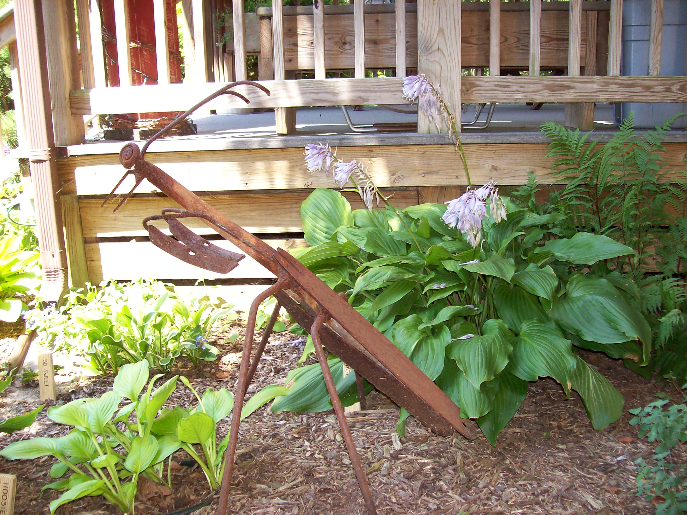

David was a real pack rat and would save everything. He got a lot of parts when Bob closed down his Foreign Car Repair Shop in Colonial Heights. Frank Arrigo, another long time friend of David, says “David had a very vivid imagination and was such a craftsman he could do almost anything. He would sit down, look and something and then think how he could make something work.”

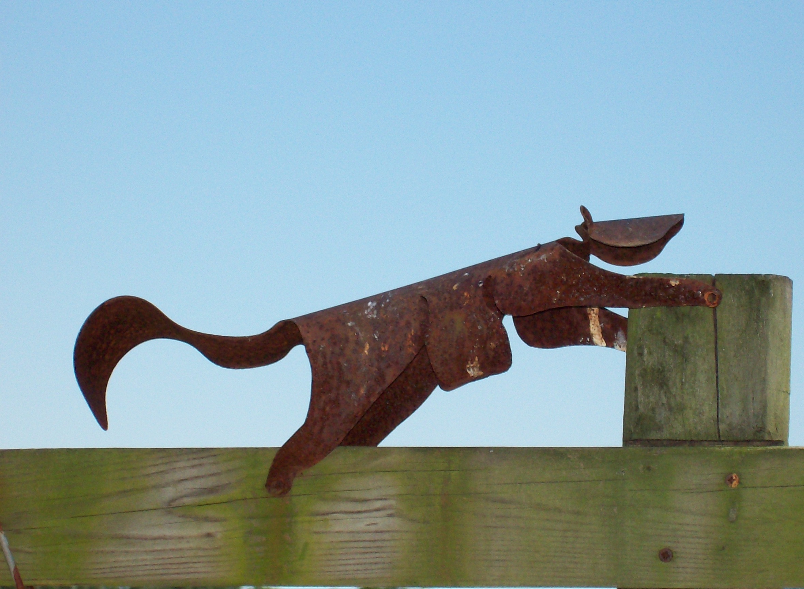

Jan and Greg Thompson probably have one of the largest collections of David’s Garden art. The Thompsons would purchase a piece every year when they went to the sale at Lewis Ginter. Most of the photos in the article were supplied by them for this article. The “Heron” sculpture was actually commissioned by them. They just had to tell David what they wanted and his creative genius made it happen!

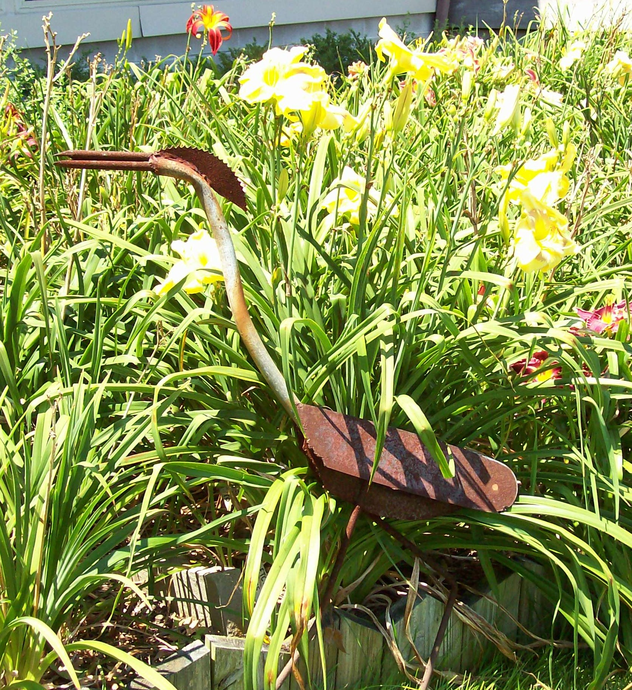

The week before David passed I had the opportunity to visit with him at his home. One of the family’s dogs kept falling into one of the little pools in the gardens and could not get out. David and I went down to a building at the edge of their property to find a board of the correct size to cover the pool. As we entered the building, I saw all types of scrap metal, sprockets, gears, etc. lying on the ground everywhere. To anyone else this would have looked like a giant junk pile, but I know that David could look at every piece as a part of a garden animal that he had not yet had time to create.



