RADS Newsletter, Winter 2014

RADS Website: http://myrads.com

Annual RADS Dues:

It’s time to send in your annual RADS membership dues. Please send your check, made out to “RADS,” for

$5 single or $8 family, to Terri Bryant at

1940 Camborne Road, North Chesterfield, VA 23236

As all of you know, we have lost several RADS members this year. Angelo, Jerry, Baskerville, Don, and Emily will all be missed by the club members. Please keep their families in your thoughts and prayers as the holidays approach.

Next Meeting:
November 29, 11:00 a.m., at the Wagner Building – This is the annual Thanksgiving meeting.

“Thank you” to everyone who served on committees, helped with the Regional, or assisted with the show this year. Regional attendees had a great time enjoying the gardens and talking with friends.
Anyone who is currently serving on a committee, who does not wish to serve in the coming year, needs to let Paulette know so that the vacated position can be filled.
Thanks again, everyone, for your commitment to RADS.
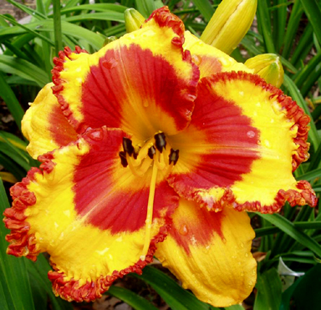

RADS Officers to be Voted on for 2015:

President
Paulette Miller
(804) 520-0807
Psm229@aol.com

Vice President
Pam Rutledge
(804) 740-0089
dayliliesrus@gmail.com

Treasurer
Leo Rutledge
(804) 740-0089
dayliliesrus@gmail.com

Secretary
Julia Perkinson
(804) 795-5874
julia.perkinson@vhda.com

Appointed Positions - 2015

Newsletter Editor
Belinda Sheppard
(434) 374-4910
belinda23955@yahoo.com

Membership Chairman
Terri Bryant
(804) 276-1260
Terri.Bryant2@verizon.net

