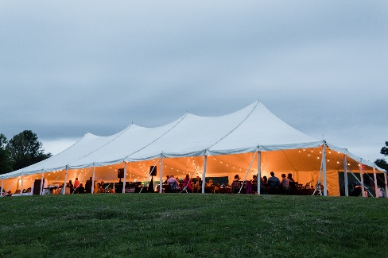
AHS REGION 3 SUMMER MEETING
DAYLILIES UNDER THE BIG TOP
JUNE 19-21, 2020
MECHANICSVILLE, VA

Hotel: Four Points by Sheraton
4700 S. Laburnum Ave Richmond, VA 23231
804-226-4300

HOST GARDEN - Ferrell Garden (15 minutes from hotel)
Address: 6210 Cold Harbor Rd. Mechanicsville, VA 23111
(Pickup Information Packets at Tent on Saturday June 20)

Contact: Paulette Miller: psm229@aol.com - 804-520-0807
Registrar: Jerry Bange: bange1@verizon.net - 410-798-9207
Information: www.ahsregion3.org

Friday, June 19 Open Gardens:
8:00 am - 1:00 pm Woodhenge Gardens - Jim and Margo – 3191 Plank Rd., North Garden, VA 22959
9:00 am - 1:00 pm Leo and Pam George Rutledge Garden – 1519 Westshire Lane, Henrico, VA 23238
Saturday, June 20 Tour Gardens, Exhibition Judges’ Clinic I, and Garden Judges’ Workshop II:
PLEASE NOTE: Gardens may be visited in any order during scheduled times. Carpooling is encouraged.

8:30 am - 2:30 pm Ferrell Garden – 6210 Cold Harbor Rd., Mechanicsville, VA 23111
9:30 am - 10:30 am Exhibition Judges’ Clinic l – Ferrell garden under tent
8:30 am - 2:30 pm Small World Gardens – 16204 Mistora Rd., Chester, VA 23831
8:30 am - 2:30 pm Lee Payne Garden – 1430 Schloss Rd., N. Chesterfield, VA 23225
10:00 am - 12:00 noon Garden Judges’ Workshop ll, Small World Gardens
4:00 pm Events Resume at Ferrell Garden
4:00 pm - 5:00 pm Business Meeting – Ferrell Garden
5:00 pm - 6:00 pm Hospitality Hour – Bring snacks to share.
6:00 pm - 7:00 pm Dinner – Catered by Brock’s BBQ.
7:00 pm - 7:30 pm Basket Raffle – Tickets available Ferrell Garden
7:30 pm - 9:00 pm Live Auction – Auctioneer: Michael Miller
Sunday, June 21 Clinic and Open Gardens
9:30 am - 12:00 noon Exhibition Judges’ Clinic II – Sheraton Hotel
8:00 am - 1:00 pm Woodhenge Gardens
8:00 am - 3:00 pm Small World Gardens

