AHS REGION 3 PRESENTS
DAYLILIES UNDER THE BIG TOP SUMMER MEETING
JUNE 19-21, 2020
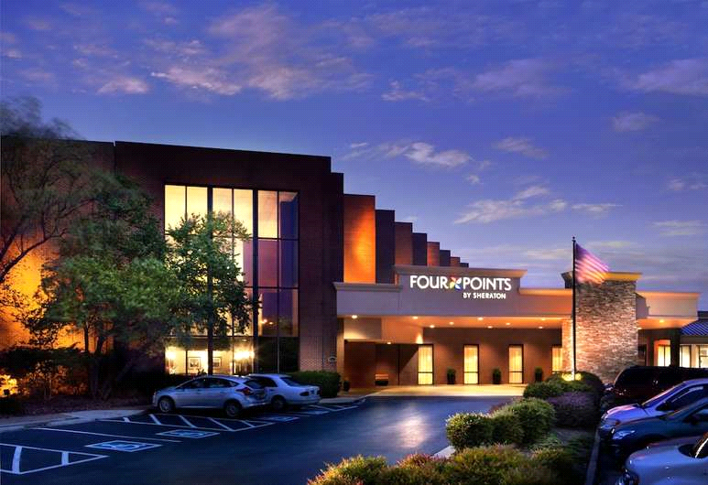
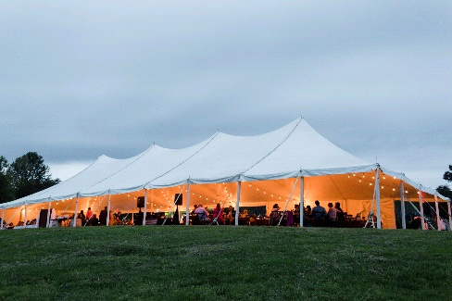
MECHANICSVILLE, VA

Hotel: Four Points by Sheraton
4700 S. Laburnum Ave Richmond, VA 23231
804-226-4300

HOST GARDEN: Ferrell Garden (15 minutes from hotel)
6210 Cold Harbor Rd., Mechanicsville, VA 23111
(Pickup Information Packets at Tent on Saturday June 20)

Contact: Paulette Miller psm229@aol.com 804-520-0807
Registrar: Jerry Bange bange1@verizon.net 410-798-9207
Program Information: www.ahsregion3.org

NAME: ____________________________________________
Print name as it should appear on name tag

ADDRESS:___________________________________________________

CITY:______________________________ ZIP:_______________________

EMAIL:_________________________________PHONE:__________________________

ADDITIONAL NAME(S): ________________________________________

REGISTRATION FEES: ADULT $75 per person. YOUTH $40 per person. Indicate by a “Y” following the name. Make checks payable to ‘RADS’ or ‘Richmond Area Daylily Society’. Mail Registration and check to: Jerry Bange at 3508 Foxhall Dr., Davidsonville, MD 21035

Check Amount: $______________

HOTEL RESERVATIONS: Please call Four Points by Sheraton directly at 804-226-4300 to make your reservation. To receive the discount rate of $109 per night (plus taxes), you must register before the cutoff date of 6/8/2020 and mention daylilies. The hotel operates a shuttle to and from the airport.

JUDGES’ CLINICS AND WORKSHOP: Please list the name(s) of persons who plan to attend. A $5 fee will be collected at each session. Attendees must bring the newest revision of the Garden Judges’ and Exhibition Judges’ Handbook (available on the AHS website).

EXHIBITION JUDGES’ CLINIC I:_______________________________________________

EXHIBITION JUDGES’ CLINIC II:_______________________________________________

GARDEN JUDGES’ WORKSHOP II :____________________________________________

